Covid-19 has stopped Paws Pet Therapy bring joy before, but this time has helped them think outside the box

Briannah Devlin

News
Southern Highlands News – 21/07/2021

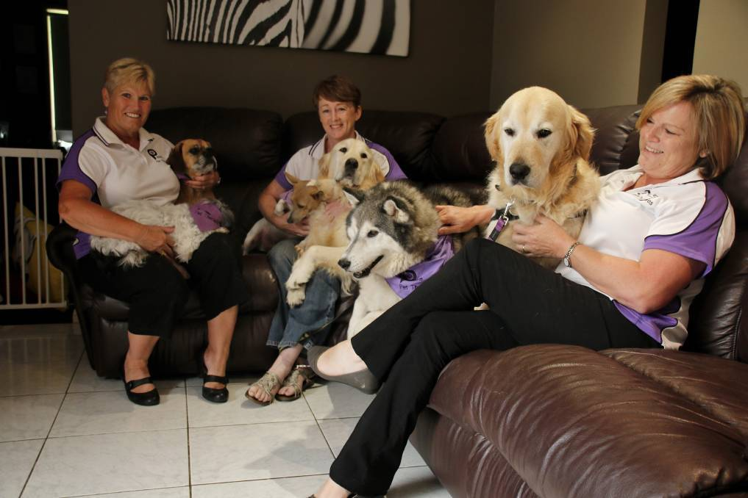
Paws Pet Therapy volunteer Maria Morton with Ben and RJ, Paws 'n' Tales co-ordinator Lisa McKay with Ringo and Rocky, and Paws Pet Therapy president Sharon Stewart with Zep and Hudson. Photo: Victoria Lee.
Paws Pet Therapy canines have brought joy to many across NSW since 2012, but have not been able to lately due to Covid-19 restrictions.
About 120 dogs and their owners stopped their regular visits to libraries, hospitals, aged care facilities and schools in late June.
Paws Pet Therapy CEO Sharon Stewart said the not-for-profit-organisation received many calls last year and this year, from individuals who struggled with restrictions.
"We were on hold for most of last year," she said.
"It was a time when people really needed us, and we could not be there for them.
"Aged-care was our biggest interest six months ago, but we have received more calls for children and adolescent mental health."
Teams in the Highlands have visited patients at the Bowral and District Hospital, the Southern Highlands Cancer Centre, and residents at Anthem Care and Harbison.
They have also supported high school students who have received vaccinations, and helped those preparing for the HSC relax, whilst they studied for their exams.
The dogs have also kept younger children company as they learn to read through the Paws 'n' Tales reading program.
Bowral Public School students have also benefited from the Mate at the Gate Program, which meant they saw a familiar face as they transitioned to school.
Mrs Stewart said the pandemic "forced" the organisation to "try different things", and think about how to reach the masses.
Upcoming programs to tackle this have included connecting with struggling youth and Australians from regional areas remotely.
Mrs Stewart said the plan was to offer the services to children first.
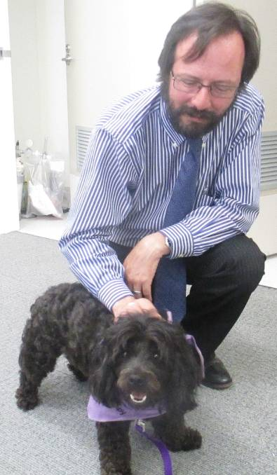

"There has been lots of interstate interest, we are close to having the videos ready," she said.
The founder said under 400 dogs have been trained since the organisation began nine years ago.
"We have heard beautiful stories that have validated what we knew all along - that the service was needed," she said.
"People have come up to me and said they remember the dogs that have supported them."
Residents can learn more information about volunteering here.

